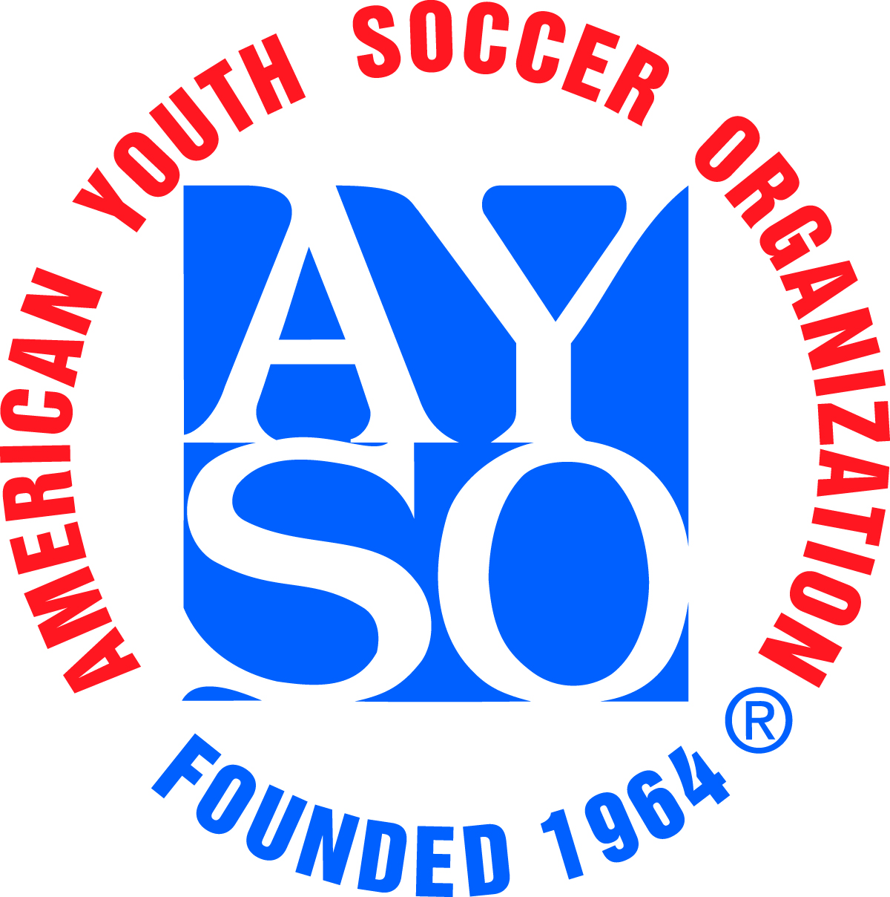 |  | 22nd Annual KICKOFFF CLASSIC  Tournament Referee Information Form
I plan to bring a referee team to the tournament Y/N: |  |  |  |  |  |  |  |  |  |  |  |  |  |  |  | Referee Information Form Date:
Region: |  |  |  |  |  | Team Name:

Coach Name:
Age Division: 8U |  |  |  | 10U |  |  |  | 12U |  |  | 14U |  |  | 16U |  |  |  | 19U |  | Boys |  |  | Girls |  |  | Coed

Referee Team Contact Person
Name: |  | Email Address:
Day Phone: |  | Evening Phone:
Provide the following information for each referee.
- For “Badge Level”, insert R = Regional, I = Intermediate, A = Advanced, N = National. Also the date they were certified at that level.
- In each box under “Referee/Assistant/Boys/Girls”, provide the highest level they are competent to referee (e.g. BU-10, GU-12, etc.)
- In “Player on Team”, indicate if the referee has a child who is playing in the tournament on this team.

 | Referee Name | Badge Level | Certifica-  tion Date | Referee |  | Assistant |  | Player on Team (Y/N) | Home Phone/ Email
 |  |  |  | Boys | Girls | Boys | Girls
1
2
3
4

Each referee will receive a tournament T-Shirt (max of 3 per Team). Please indicate sizes needed. All sizes are Adult.
 | XXL | XL |  | L |  | M | S
Number of Shirts Needed
Regional Referee Administrator’s Name |  |  |  |  | Phone Number |  |  |  |  | Email
By my signature below, I certify that all referees listed are trained and Safe Haven certified AYSO referees and qualified for officiating 8U through 14U games as indicated above.
RRA Signature and date (Blue ink please)

Area Referee Administrator’s Name |  | Phone Number |  | Email
By my signature below, I certify that all referees listed are trained and Safe Haven certified AYSO referees and qualified for officiating 16U and 19U games as indicated above.
ARA Signature and date (Blue ink please)

